**21st Century Literature**

Government Property

**NOT FOR SALE**

**Senior High School**

**from the Philippines and the World**

**Quarter 1 – Week 3**

Name of Learner: ___________________________________ Date: ________________

Grade Level: _____________________________ Section: ________________________

**LEARNING ACTIVITY SHEET**

**21st Century Literary Genres**

1. **MOST ESSENTIAL LEARNING COMPETENCY WITH CODE**

Compare and contrast the various 21st century literary genres and the ones from the earlier genres/periods citing their elements, structures and traditions.

Code: **EN12Lit-Id-25**

**Specific Objective:**

1. Identify the different 21st Century literary genre, and
2. Compare and contrast the various 21st century literary genres citing their elements, structures and traditions.
3. **BACKGROUND INFORMATION**

This Learning Activity sheet is a standalone section that you can use based on your needs and interests to enhance your competency on how to differentiate the various 21st century literary genres and the ones from the original genres, citing their elements, structures and traditions.

1. **GENERAL DIRECTIONS**

To achieve the objectives of this module, do the following:

1. Take your time reading the lessons carefully.
2. Follow the directions and/or instructions in the activities and exercises diligently.
3. Answer all the given tests and exercises.
4. **LEARNING ACTIVITIES**
5. **EXPLORE**.

**Activity 1:** Look for the conventional literary genres in the puzzle below and, on a separate sheet of paper, answer the questions that follow.

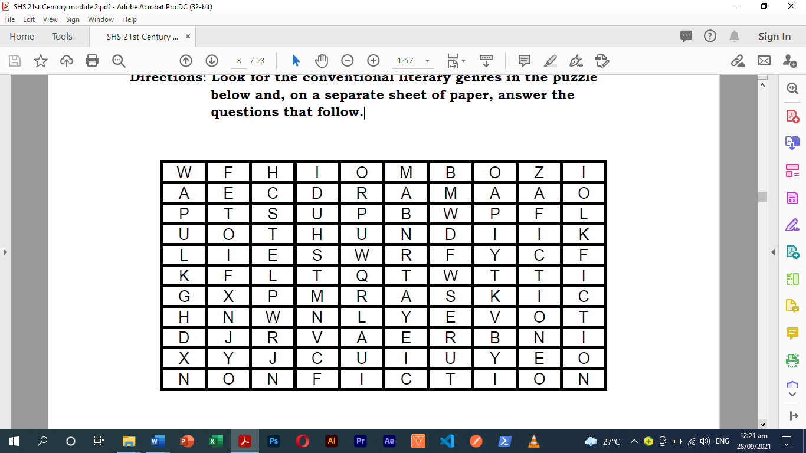

1. What are the four conventional literary genres have you found in the puzzle?
2. What are their unique features?
3. **LEARN**

**Let’s recall the major literary genres!**

**POETRY**- is an imaginative awareness of experience expressed through meaning, sound and rhythmic language choices to evoke an emotional response. It has been known to employ meter and rhyme. The very nature of poetry as an authentic and individual mode of expression makes it nearly impossible to define.

**DRAMA**- is a composition in prose or verse presenting in dialogue or pantomime a story involving conflict more contrast of character, especially on intended to be acted on a stage: a play. It may be any situation or series of events having vivid, emotional, conflicting or striking interest.

**FICTION**- is literature created from the imagination, not presented as fact, though it may be based on a true story or situation. Types of literature in the fiction include the novel, short story and novella.

**NON-FICTION**- is based on facts and the author’s opinion about a subject. The purpose of non-fiction writing is to inform and sometimes to persuade. Its examples are biographies, articles from textbooks and magazines and newspapers.

You have rediscovered the conventional literary genres. Now you will learn modern literary genres presently used by 21st century writers.

**21ST CENTURY LITERATURE GENRES**

**ILLUSTRATED NOVEL**

* Story through text and illustrated images
* 50% of the narrative is presented without words
* The reader must interpret the images to comprehend the story completely.
* Textual portions are presented in traditional form.
* Some illustrated novels may contain no text at all.
* Span all genres.
* Examples include **The Invention of Hugo Cabret** by Brian Selznick and **The Arrival** by Shaun Tan.

**DIGI-FICTION**

* Triple Media Literature
* Combines three media: book, movie/video and internet website. To get the full story, students must engage in navigation, reading, and viewing in all three forms.
* Patrick Carman’s **Skeleton Creek** and Anthony Zuiker’s **Level 26** are examples.

**GRAPHIC NOVEL**

* Narrative in comic book formats
* Narrative work in which the story is conveyed to the reader using a comic form.
* The term is employed in broadly manner, encompassing non-fiction works and thematically linked short stories as well as fictional stories across a number of genres.
* **Archie Comics** by John Goldwater and illustrator, Bob Montana, is a good example.

**MANGA**

* Japanese word for comics
* It is used in the English-speaking world as a generic term for all comic books and graphic novels originally published in Japan.
* Considered as an artistic and storytelling style.
* Ameri-manga- sometimes used to refer to comics created by American artists in manga style.
* Shonen- Boy’s Manga (**Naruto, Bleach, One Piece**)
* Shojo- Girl’s Manga (Sailormoon)
* Seinen- Men’s Manga (Akira)
* Josei- Women’s Manga (**Loveless, Paradise Kiss)**
* Kodomo- Children’s Manga (**Doraemon, Hello Kitty**)

**DOODLE FICTION**

* Literary presentation where the author incorporates doodle writing, drawings and handwritten graphics in place of the traditional font.
* Drawing enhances the story, often adding humorous elements
* Examples include **The Diary of a Wimpy Kid** by Jeff Kinney and **Timmy Failure** by Stephan Pastis.

**TEXT-TALK NOVELS**

* Blogs, email and IM format narratives
* Stories told almost entirely in dialogue simulating social network exchanges.

**CHICK LIT or CHICK LITERATURE**

* Is genre fiction which addresses issues of modern womanhood, often humorously and lightheartedly.
* Chick Lit typically features a female protagonist whose femininity is heavily thermalizing in the plot.
* Scarlet Bailey’s **The night before Christmas** and Miranda Dickinson’s **It started with a Kiss** are examples of this.

**FLASH FICTION**

* It is a style of fictional literature of extreme brevity.
* There is no widely accepted definition of the length and category. It could range from word to a thousand.

**SIX-WORD FLASH FICTION**

* Ernest Hemingway: For sale: baby socks, never worn.
* Margaret Atwood: Longed for him. Got him, Shit.

**CREATIVE NON-FICTION**

* Also known as literary non-fiction or narrative non-fiction
* genre of writing that uses literary styles and techniques to create factually accurate narratives.
* Contrasts with other non-fiction, such as technical writing or journalism, which is also rooted in accurate fact, but is not primarily written in service to its craft.
* As a genre, creative non-fiction is still relatively young and is only beginning to be scrutinized with the same critical analysis given to fiction and poetry.
* **1000 Gifts** by Ann Voscamp and **Wind, Sand, and Stars** by Antoine de Saint-Exupery are examples.

**SCIENCE FICTION**

* Is a genre of speculative fiction dealing with imaginative concepts such as futuristic science and technology, space travel, time travel, faster than light travel, a parallel universe and extra-terrestrial life.
* Often explores the potential consequences of scientific and other innovations and has been called a “literature of ideas”.
* Examples include Suzanne Collins’ **Mockingjay** and Sarah Maas’ **Kingdom of Ash.**

**BLOG**

* A weblog, a website containing short articles called posts that are changed regularly.
* Some blogs are written by one person containing his or her own opinions, interests and experiences, while others are written by different people.

**HYPER POETRY**

* Digital poetry that uses links and hypertext mark-up
* It can either involved set words, phrases, lines, etc. that are presented in variable order but sit on the page much as traditional poetry does, or it can contain parts of the poem that move and transform.
* It is usually found online, through CD-ROM and diskette versions exist. The earliest examples date to no later than the mid-1980’s.

1. **ENGAGE**

**Activity 2:** Write the similarities and differences of the Doodle Fiction, Manga and Graphic Novel using the Compare and Contrast Graphic Organizer.

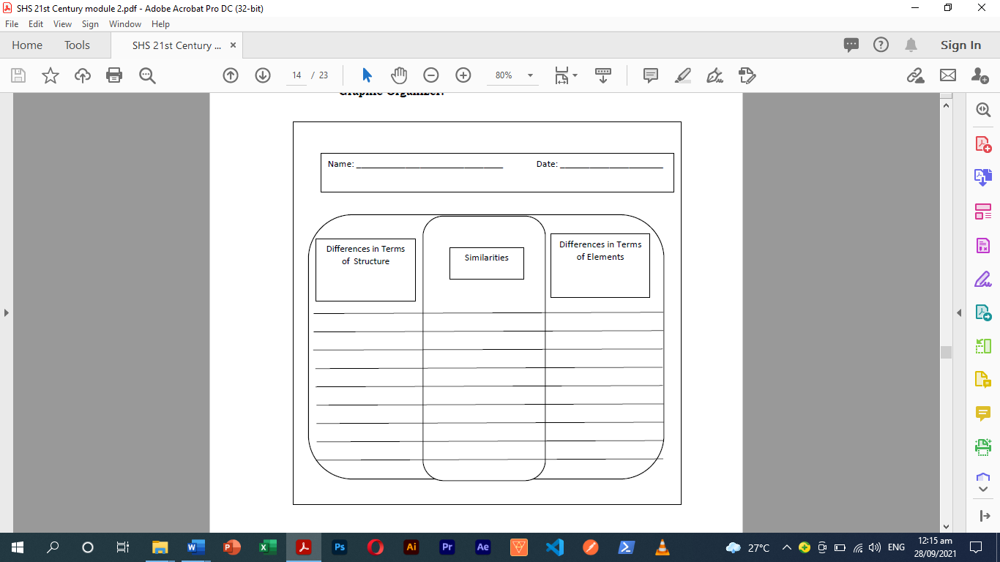

1. **APPLY**

**Activity 3:** Read and understand each item carefully. Choose the letter of the best answer. Write the chosen letter on a separate sheet of paper.

1. A story told using a combination of text and illustrations or without text at all.

A. Digi-Fiction B. Doodle Fiction

C. Illustrated Novel D. Creative Non-Fiction

1. A site of collected posts or articles written by one or more people and updated regularly.

A. Blog B. Flash Fiction

C. Hyper Poetry D. Digi-Fiction

1. Brief stories told in a thousand words or less.

A. Blog B. Flash Fiction

C. Hyper Poetry D. Digi-Fiction

1. Tales are written and presented using dialogues in social media applications.

A. Chick Lit B. Digi-Fiction

C. Hyper Poetry D. Text-talk Novel

1. A factual story is written using literary devices and techniques.

A. Digi-Fiction B. Doodle Fiction

C. Illustrated Novel D. Creative Non-Fiction

1. Drawings enhance stories in this form where illustrations and handwritten graphics are incorporated.

A. Digi-Fiction B. Doodle Fiction

C. Illustrated Novel D. Creative Non-Fiction

1. The genre of speculative fiction dealing with concepts of time, travel, parallel universe, extra-terrestrial life, and futuristic technology.

A. Digi-Fiction B. Doodle Fiction

C. Science Fiction D. Creative Non-Fiction

1. It is a collection of stories presented in comic book formats.

A. Digi-Fiction B. Doodle Fiction

C. Illustrated Novel D. Graphic Novel

1. Literature that uses hypertext mark-up (HTM) to connect to other parts of the piece.

A. Blog B. Flash Fiction

C. Hyper Poetry D. Digi-Fiction

1. In English-speaking countries, these are stories with illustrations published in Japan.

A. Manga B. Digi-Fiction

C. Graphic Novel D. Illustrated Novel

1. A 700-word story like **Angels and Blueberries** by Tara Campbell is a one-shot fiction that falls under this literary genre.

A. Blog B. Flash Fiction

C. Hyper Poetry D. Digi-Fiction

1. Christopher Ford’s **Stickman Odyssey**, which tells the story through text and handwritten graphics, is an example of this literary genre.

A. Digi-Fiction B. Doodle Fiction

C. Illustrated Novel D. Creative Non-Fiction

1. Before it was adapted into an anime, **Yoshihiro Togashi’s** Hunter x Hunter is a comic book series from Japan that falls under this literary genre.

A. Manga B. Digi-Fiction

C. Graphic Novel D. Illustrated Novel

1. **Batman: The Dark Knight** by Frank Miller is a popular example of this literary genre where the story is written in comic book format.

A. Manga B. Digi-Fiction

C. Graphic Novel D. Illustrated Novel

1. Sophie Kinsella’s **Confessions of a Shopaholic**, which revolves around a woman’s shopping addiction and her journey to overcoming it, is an example of this literary genre.

A. Chick Lit B. Digi-Fiction

C. Hyper Poetry D. Text-Talk Novel

1. **REFERENCES**

Cadacio R. and Caturay F. (2020). *21st Century Literature from the Philippines and the World Alternative Delivery Mode Quarter 1 – Module 2: Conventional and 21st Century Literary Genres First Edition, 2020*.

1. **ANSWERS KEY**

**Activity 1**



**Activity 2**

There is no specific answer to this activity. Answers may vary from student to student.

**Activity 3**

1. **C**
2. **A**
3. **B**
4. **D**
5. **D**
6. **B**
7. **C**
8. **D**
9. **C**
10. **A**
11. **B**
12. **B**
13. **A**
14. **C**
15. **A**

Prepared by: Checked by:

**JOVITO R. ABIO** **JASMIN A. CHEN**

Subject Teacher English Department Head

Noted:

**SHIRLY M. SOLIOT**

Assistant Principal II

Approved:

**ELSA V. RIPALDA PhD**

Principal IV